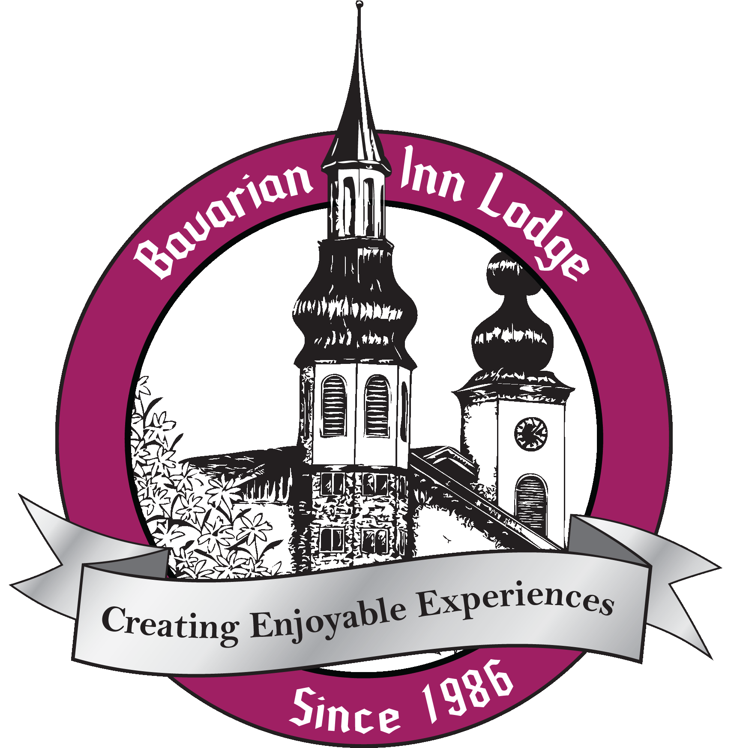

Bavarian Inn Lodge Fact Sheet – 2022

- Bavarian Inn Lodge (www.bavarianinn.com) is one of America’s largest Bavarian-themed resorts with 360 guest rooms and a full-function conference center. Originally opened in 1986, the Lodge has undergone six development phases:

- Phase I (1986): $5 million creation of 100 guest rooms, one indoor pool, a restaurant and lounge and a banquet facility;
- Phase II (1989): $5 million addition including 98 guest rooms, second indoor pool and family fun center;
- Phase III (1995): $14 million addition including156 guest rooms, gift shop, third indoor pool, second restaurant and lounge, 18-hole indoor mini-golf course addition to fun center;
- Phase IV (1998): $3.5 million 500-seat conference center;
- Phase V (1999): $1.5 million addition of two more indoor pools;
- Phase VI (2012): $3 million installation of two water slides and refresh of mini-golf course.
- Phase VII (2024): $80 million water park and family entertainment expansion announced with groundbreaking in December 2022.

- R.C. Hendrick, general contractor and construction manager located in Saginaw, Mich., built every phase of the Bavarian Inn Lodge.

- Each guestroom in the Lodge is named to honor a local Frankenmuth family. The Lodge has celebrated over 2,200 weddings and thousands of events and meetings.

- Among the features of this seven-acre, multi-faceted resort are: 360 guest rooms with family and whirlpool suites; a waterpark complex with two water slides; four pools and three whirlpools; gaming center with over 160 games; 18-hole indoor miniature golf course; three restaurants; two gift shops; free WiFi internet; and a conference center that accommodates up to 500 people for weddings, special events and meetings or conventions.

- Opening in February 1986 with 100 guest rooms, a dining room, lounge and indoor pool, the Bavarian Inn Lodge quickly became an important destination for travelers to Frankenmuth, as evidenced by the 2.5 million room-nights booked there since its opening.
- Bavarian Inn Lodge’s mantra is to “think like a big bed and breakfast,” encouraging staff at all levels to be friendly with guests and “have fun” in their jobs.
- Bavarian Inn Lodge is ranked #1 on TripAdvisor.com and is the most reviewed hotel in Michigan. Other distinctions include: Greatest of the Great Lakes Bay’s 2015 ranking as “Best Wedding Venue” and for having the “Best Mini-Golf Course;” the 2015 Knot Best of Weddings Award; the 2014 & 2015 Family Vacation Favorite Awards; Judy Zehnder as 2015 RD Musser Hotelier of the Year; Saginaw Valley State University’s (SVSU) College of Business and Management 2015 Outstanding Family Business Award as part of Bavarian Inn Corp.
- The adjacent Bavarian Inn Restaurant, best known for its Frankenmuth® Chicken Dinners, is one of the top independent restaurants in the United States with seating for 1,200 guests. Proud of its numbers, the Inn served a record 5,470 meals on October 9, 1982, and more than 20 million meals in its first 100 years (1888 through 1988). Annually, it has served more than 900,000 meals.

- Spanning more than 135 years in hospitality service, four generations of the Tiny and Dorothy Zehnder family have owned and operated the Frankenmuth Bavarian Inn Restaurant and Lodge. With 900-1000 employees currently on the payroll, Dorothy Zehnder (Generation Two) is still working with her children (Generation Three) and five grandchildren (Generation Four) for a total of ten on-site owners who make their living on-site, every day, year-round leading 100+ managers and supervisors.

- In 1999, Bavarian Inn created its Bavarian Inn Perks Club as a way to get to know and reward its best customers. Winner of COLLOQUY Magazine’s 2015 Independent Loyalty Award and Loyalty360’s Best Reward/Loyalty Silver Award, the program’s more than 35,000 current members are offered discount programs at all Bavarian Inn Corp entities as well as “soft benefits” like watching fireworks with the Bavarian Inn Zehnder family.

- The Bavarian Inn has been host to many dignitaries over the years including: President George H. W. and Mrs. Bush, Michigan Governor Rick Snyder and all Michigan governors dating back to G. Mennen Williams.

- Against the backdrop of authentic architecture of southern Germany, the city of Frankenmuth attracts millions of visitors who come from near and far to experience the European charm, food, hospitality and other fun activities that are the hallmark of one of Michigan’s top tourist attraction cities.
- Settled by a community of German immigrants in the mid 1840’s, Frankenmuth is lovingly known as Michigan’s “Little Bavaria.” The city owes much to the Bavarian Inn Zehnder family, including its infrastructure, downtown development and thriving business district.

On Site Contact: Joanna Stratman  jstratman@bavarianinn.com  989-480-7927 (office)  989-652-7200 (hotel) | Agency Contact: Sue Voyles  sue@logos-communications.com  734-667-2005  734-635-3831 (mobile)

