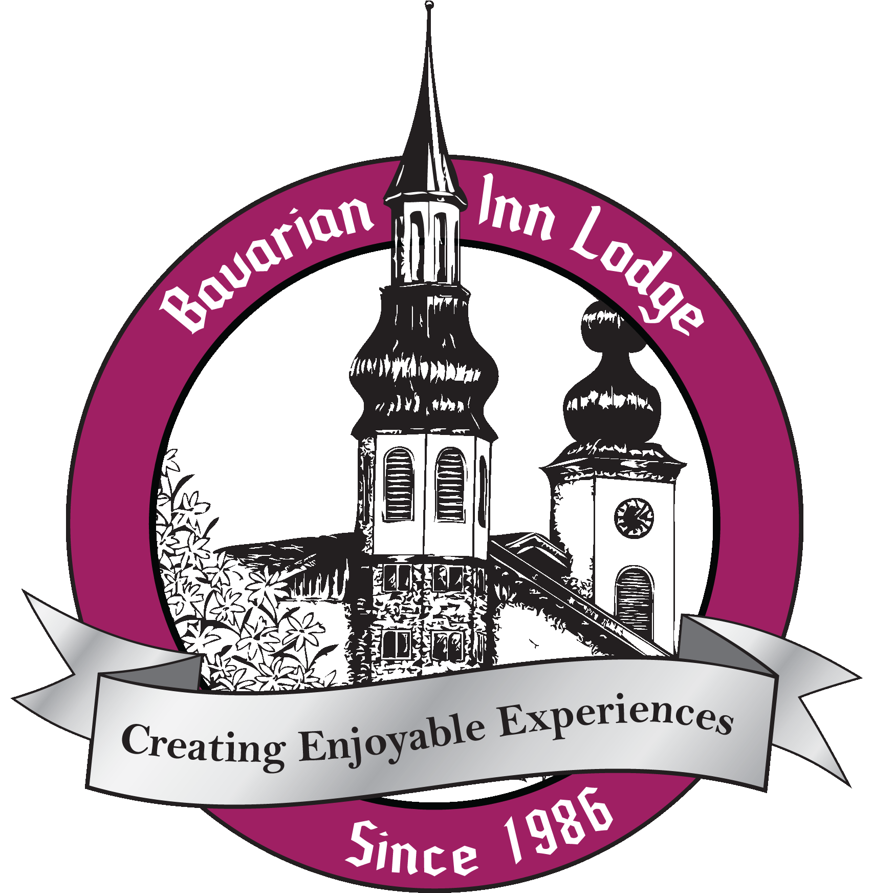

Bavarian Inn Lodge Fact Sheet

- The latest renovation to the Bavarian Inn Lodge is a $3 million refresh of the family fun center. This investment includes the addition of two dramatic water slides (a body slide and a multi-person tube slide) and a facelift to the mini-golf area. Both projects are planned for completion before Thanksgiving 2012.
- Bavarian Inn Lodge (www.bavarianinn.com) is one America’s largest Bavarian-themed resorts with 360-guestrooms and full-function conference center. Originally opened in 1986, the Lodge has undergone six phases:
- Phase I (1986): $5 million 100 guestrooms, one indoor pool, a restaurant and lounge, and a banquet facility;
- Phase II (1989): $5 million addition including 98 guest rooms, second indoor pool and family fun center;
- Phase III (1995): $14 million addition including156 guest rooms, gift shop, third indoor pool, second restaurant and lounge, 18-hole indoor mini-golf course, addition to fun center;
- Phase IV (1998): $3.5 500-seat conference center;
- Phase V (1999): $1.5 million addition of two more indoor pools;
- Phase VI (2012): $3 million installation of two water slides and refresh of mini-golf course.
- R.C. Hendrick, general contractor and construction manager located in Saginaw, Mich., built every phase of the Bavarian Inn Lodge.
- Each guestroom in the Lodge is named to honor a local Frankenmuth family. The Lodge has celebrated more than 1,600 weddings and thousands of special events and meetings.
- Among the features of this seven-acre, multi-faceted resort are: four indoor pools, 18-hole indoor miniature golf course, two restaurants, two gift shops, free WiFi internet and a conference center that can accommodate up to 500 people and is perfect for hosting conventions at the local, regional or national level.
- The adjacent Bavarian Inn Restaurant, best known for its Frankenmuth® Chicken Dinners, is one of the top 10 independent restaurants in the United States with seating for 1200 guests. Proud of its numbers, the Inn served a record 5,470 meals on October 9, 1982, and more than 20 million meals in its first 100 years (1888 through 1988).
- Against the backdrop of authentic architecture of southern Germany, the city of Frankenmuth attracts millions of visitors who come from near and far to experience the European charm, food, hospitality and other fun activities that are the hallmark of one of Michigan’s top tourist attraction cities.
- Settled by a community of German immigrants in the mid 1840’s, Frankenmuth is lovingly known as Michigan's "Little Bavaria." The village owes much to the Zehnder family, including its infrastructure, downtown development and thriving business district.
- Spanning nearly 125 years in hospitality service, four generations of the Tiny and Dorothy Zehnder family have owned and operated the Frankenmuth Bavarian Inn Restaurant and Lodge. With more than 900 employees currently on the payroll, Dorothy Zehnder (Generation Two) is working with her children (Generation Three) and four grandchildren (Generation Four) for a total of nine on-site owners working in the company full-time.
- The Bavarian Inn has been host to many dignitaries over the years including: President George H. W. and Mrs. Bush, Michigan Governor Rick Snyder and all Michigan governors dating back to G. Mennen Williams.
- In 25 years of business, the Bavarian Inn Lodge has been an important destination for travelers, evidenced by the 1.25 million room-nights that have been booked there since its opening.
- Judy Zehnder Keller designed, developed and leads the Bavarian Inn Lodge’s seven-acre facility.

On Site Contact: Joanna Stratman Agency Contact: Sue Voyles
jstratman@bavarianinn.com sue@logos-communications.com
989-480-7927 (office) 734-667-2005
989-652-7200 (hotel) 734-635-3831 (mobile)

