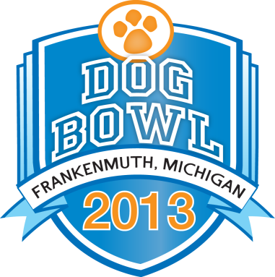

Photo Caption: Daring dogs of all sizes make a splash at the DockDogs Competition at Frankenmuth River Place Memorial weekend. It’s part of the 2013 Dog Bowl -- a national event hosting thousands of dogs in fun and sporting activities.

Frankenmuth Going to the Dogs
For Annual Olympic-Style Dog Event
River Place Shops Hosts Thousands of Canines for 2013 ‘Dog Bowl’

May 2, 2013 - Frankenmuth, Mich. - While dogs weren’t allowed at the first Olympic games in Greece, dogs of all types are welcome at the 2013 Dog Bowl Memorial Weekend. Canine athletes from across the nation will participate in a variety of events May 25 and 26, 9:00 a.m. to 6:30 p.m. at Frankenmuth River Place Shops. The sporting and fun activities are open to champion canines and couch potatoes alike, as well as their human companions. Spectators are invited at this lively, fun-filled, which hosts 40 exhibitors offering pet-related products and kid-friendly games.

“We encourage families to bring their pets and create some great memories,” says Michael Zehnder, Dog Bowl Event Chairman. “A few of the events feature top-caliber dogs competing for national titles. With or without a dog, you’ll have a great time enjoying these canine Olympics.”

Whether it’s watching DockDogs belly flop in a Diving Competition, the Rock-N-Roll K-9’s or Silly Pet Tricks, there’s something to enjoy for everyone in the family. A complete schedule of the weekend’s events is available at www.dogbowlfun.com. Here are a few highlights:

- Wiener Dog Races: Dachshunds compete for $1,000 in prizes. All Wieners welcomed!
- National DockDogs Competition: Diving dogs compete for distance, height and speed.
- Border Collie Sheep Herding Demonstrations: Collies move sheep within a fenced area.
- Disc Dog Competition: Dogs demonstrate a variety of acrobatic skills.
- Canine Cruise: Cruise Cass River with your pet on the Bavarian Belle paddle wheel boat.
- Annual Pet Parade: Join the parade with your pet or bring a lawn chair to catch the view.
- The Best Canine Costume Contest: Winners need creativity and tolerance to take this trophy.
- Silly Pet Tricks: If your dog talks, walks or is just a ham, this is the event for you.
- Rock-N-Roll K-9’s Performance Team: Dogs perform to a Rock-N-Roll musical show.
- 25-Yard Small Doggie Fun Run Race/ 50-Yard Big Doggie Fun Run Race: Big or small, find out who’s the fastest on four paws.
- Doggie Dash De Lure Races: Watch the beginners and pros race after a squirrel on the track.
- Agility Competitions and Fun Runs: Watch a large variety of dogs racing through and around obstacles.

Other activities include a doggie fashion show, dog breeds of the world show, K-9 police dog demonstrations, and crowning of the Dog Bowl King and Queen. Additionally, over 30 rescue organizations from across Michigan will be onsite with adoption dogs looking for forever homes. To print a detailed schedule for 2013 Dog Bowl visit www.dogbowlfun.com. For more information, call 1-800-600-0105.

About Frankenmuth River Place Shops
Frankenmuth River Place Shops (www.frankenmuthriverplace.com) is an authentic re-creation of a Bavarian village located just minutes from the Bavarian Inn Restaurant and Lodge. The outdoor mall features more than 40 shops and attractions at one location. Visitors enjoy architecture, floral gardens, streams and waterfalls, and of course great shopping opportunities. Sign up for the free River Place newsletter at http://frankenmuthriverplace.com/newsletter/

Media contacts:
Sue Voyles, 734.667.2005 sue@logos-communications.com
Michael Zehnder, 989-798-2306 michael@bavarianinn.com
Photo Gallery http://dogfunfest.com/photo-gallery/

